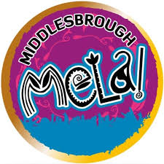
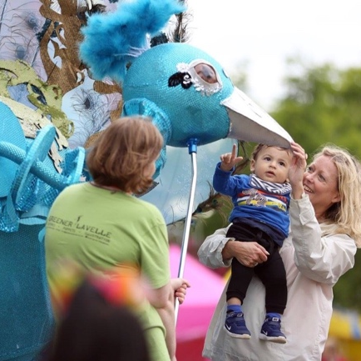
s

Artist Commissions:
Middlesbrough Mela 2021

INFORMATION PACK
Large Print Version

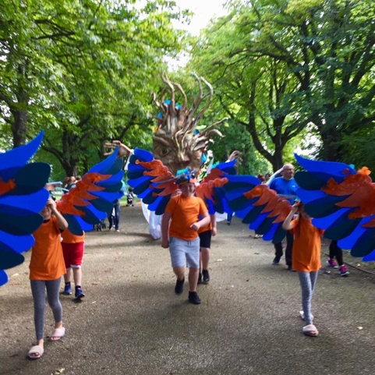
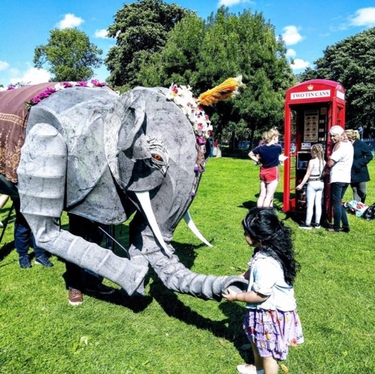

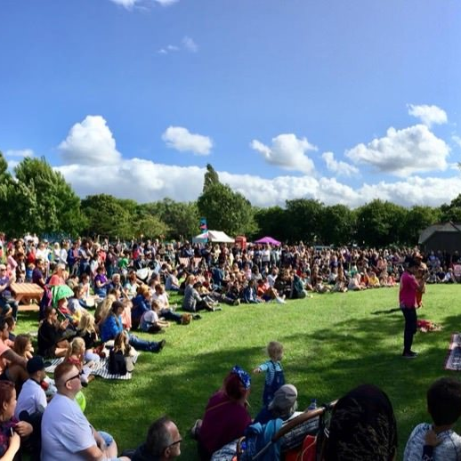

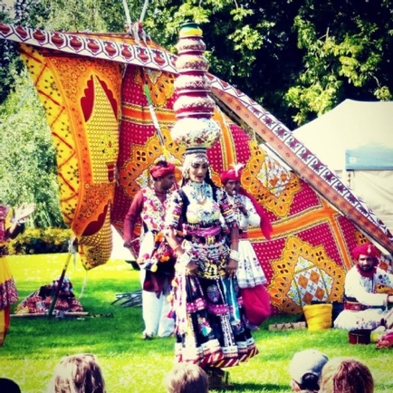
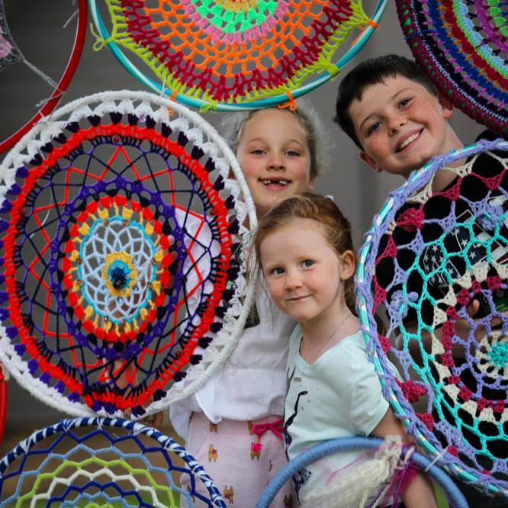

Middlesbrough Mela has two artist commission opportunities to animate the site for this year’s festival happening in Albert Park on Sunday 8 August 2021.

Commission: £2,500

The closing date for Stage One applications is Sunday 13 June at midnight.

If your Stage One application is successful, you will be invited to an online meeting with Creative Programmes Manager, Museums Manager and Festival Manager to discuss your application.

Thank you for your interest in applying for the artist commission.

This pack is also available in:
- Easy read
- Audio recording

If you need any additional support, please contact the Festival Manager on amy@middlesbroughmela.co.uk

Table of Contents
Context 3
About the commissions 4
Photos of the site 5
Who can apply? 8
Selection criteria 9
How to apply? 9
Stage Two 10

Context

Middlesbrough Mela is one of the biggest and most spectacular multi-cultural festivals in the North-East and offers a fabulous mix of music, food, fashion and fun over two days!

Set in the beautiful surroundings of Albert Park in the heart of Middlesbrough you can expect world class music, local talent, the market bazaar and a range of exciting family activities for all the family.
Middlesbrough Mela is the largest and longest established event of its kind and attracts audiences of 50,000 over two days, reflecting the aspirations and needs of the communities within Middlesbrough, the Tees Valley and beyond.
The Mela brings communities together to celebrate and promote the diverse cultures within the region by playing host to a high-quality programme of world class music covering a rich mix of hip hop, Bhangra and traditional Asian sounds, Market Bazaar, street theatre, family fun zone and fun fair.

Due to the global pandemic, we delivered last year’s festival online. With thanks to funding from Arts Council England, UNISON, Tees Valley Community Foundation and Middlesbrough Council we commissioned our very own Mela story ‘Sara’ and a range of exciting digital workshops which people could take part in and celebrate the much-loved Middlesbrough Mela at home.

This year, as restrictions begin to ease, we’re delivering three smaller micro Mela festivals, that are more suit to the current COVID-19 climate. On Sunday 8 August, at Albert Park, we will be focusing on family activities with arts and crafts, theatre, music, food, dance and a fun fair.

About the commissions

There are two commissions aimed at artists who want to create something new and wonderful to animate the site at Albert Park during Middlesbrough Mela festival.

We are interested in ideas and designs that make areas of the park more exciting, fun and enjoyable for families. The designs should embody the values of a multi-cultural festival and create wonder in a place that is known well by locals. We would love something that is bold and vibrant for that festival feeling.

We would like the creation to be used for future Mela festivals. Families will come to recognise the creation when they come back to Mela each year.

Your proposal might be signage, flag, costume, mural, crochet art, installation or something completely different. We are interested to know how you think it will inspire families and how it links to communities and cultures in Middlesbrough.

The budget is to cover all material costs and artistic fee in producing a product or item that will belong to Middlesbrough Council to be used at future Mela events.

Completed work should be ready to be presented at the festival on Sunday 8th August.

We will be awarding a maximum of two commissions of £2,500 each. We encourage submissions from artists whose are based locally and would benefit from the support Middlesbrough Council is able to offer to make it happen. We also encourage you to think about sustainability and whether you can use recycled materials.

Photos of the site

For this commission, we thought it would be helpful to be able to see areas of the park that you make draw inspiration from or where you would like to place the piece of work.
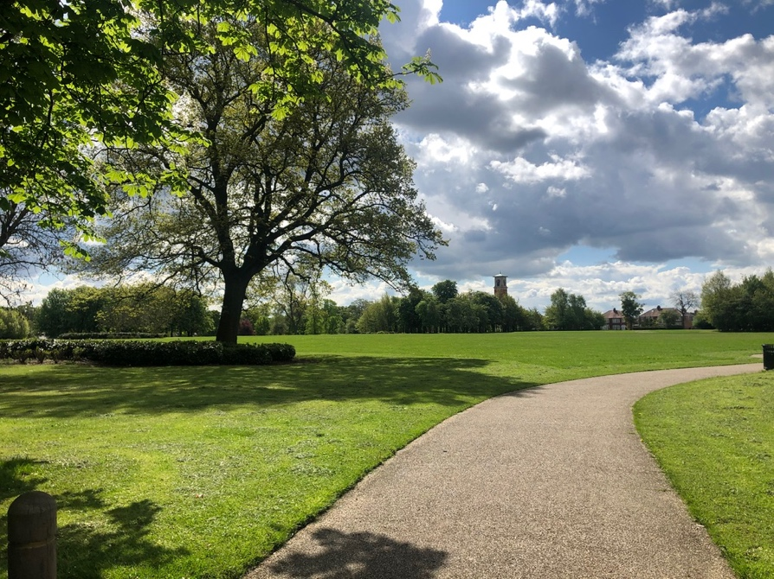

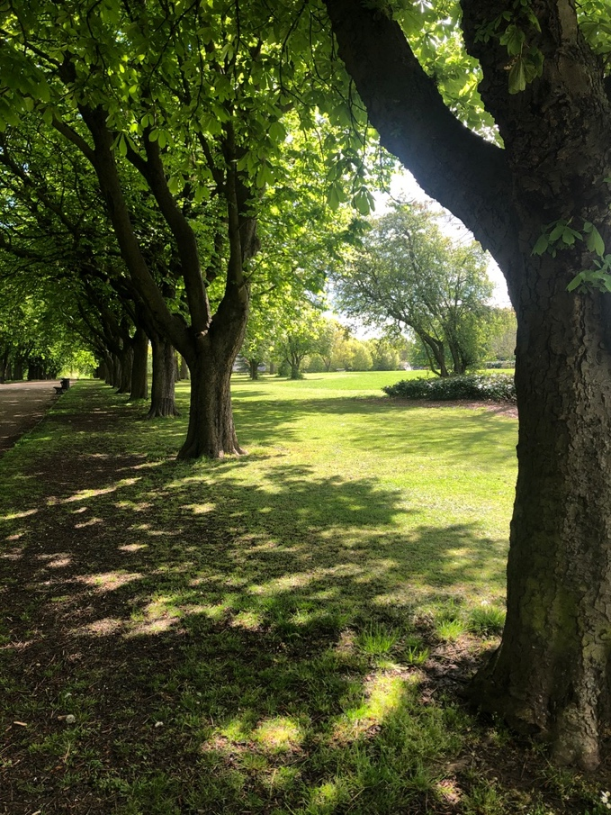

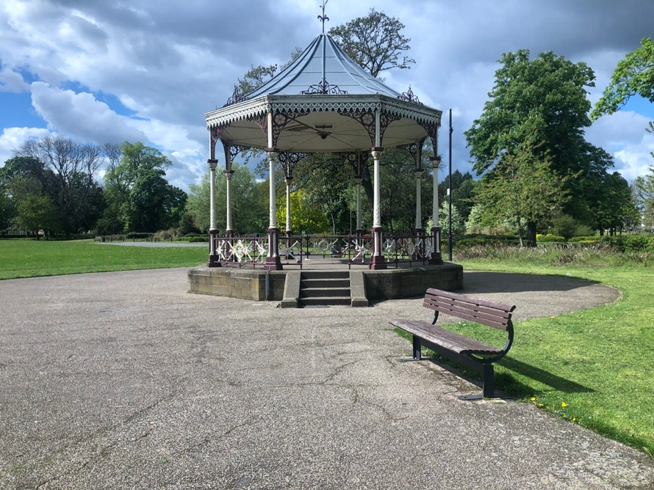

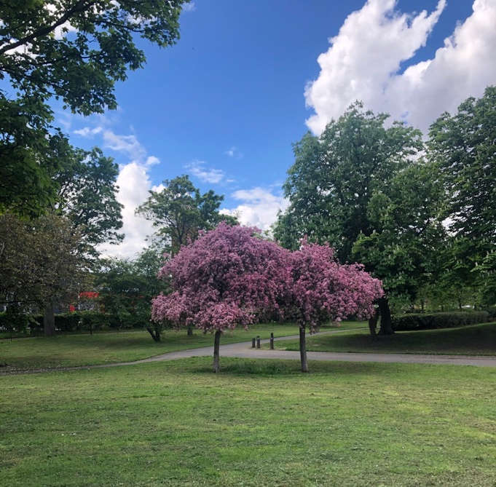

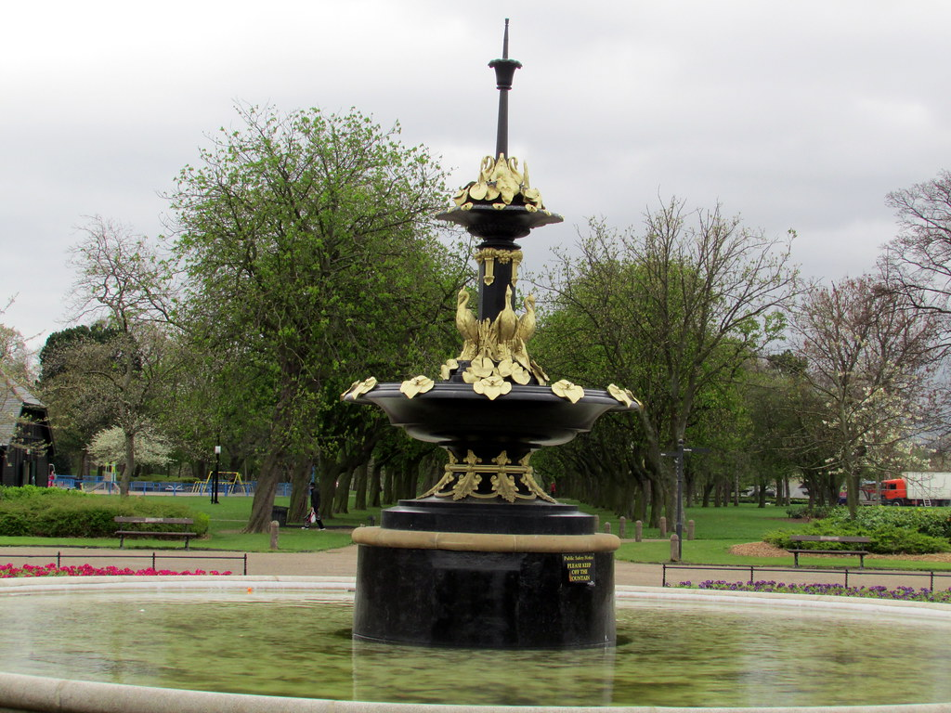

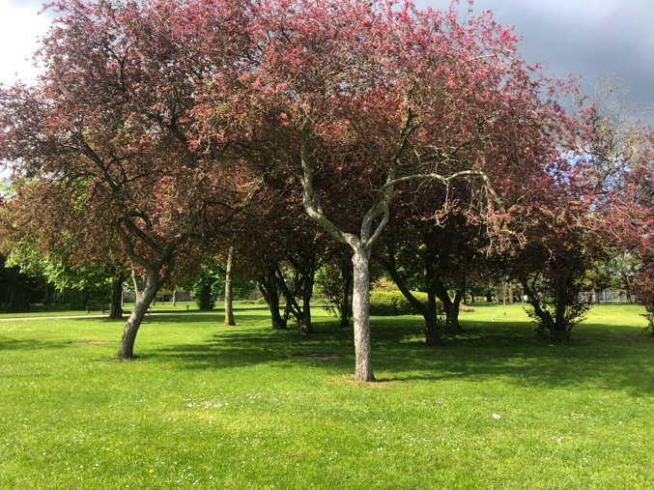

Who can apply?

The commissions are open to artists aged 18 or above from anywhere in the UK.

We are particularly interested in hearing from:
- Teesside/Middlesbrough based artists
- North East based artists
- Those would identify as People of South, East, West and Central Asian heritage, African and Caribbean heritage and mixed heritage
- Those who identify as d/Deaf and Disabled

Selection criteria

Commissions will be given based on:

- The quality of your idea
- How inspiring it will be for families visiting Middlesbrough Mela
- Legacy of the creation
- Value for money

How to apply?

Complete our short Application Form followed by an Equal Opportunities Form.

The application form will allow you to tell us more about your work, outline your idea and how it links to Middlesbrough, the Mela, local communities and families. Please feel free to just focus on one area of where its strongest connection is i.e. engages families.

We ask you to give an overview of your budget and what materials you intend to use and how you’ve considered sustainability i.e. using recycling materials.

There is a space to attach any drawings or photos that will help us better understand your idea.

Applications can be submitted online via this link – https://middlesbroughmela.co.uk/apply/ or through an easy read version that can be downloaded and emailed to amy@middlesbroughmela.co.uk

If you’d like to submit a video application, please include the information listed in the application and submit a video no longer than 3 minutes in length. This can be sent via We Transfer (or similar software) direct to amy@middlesbroughmela.co.uk along with an Equal Opportunities Form which can be filled in here: https://middlesbroughmela.co.uk/equal-opportunities/

The deadline for Stage One applications is Sunday 13 June 2021 at midnight.

Please do not send hard copies as they will not be considered.

Stage Two

If your Stage One application is successful, we will invite you to a Teams meeting with Creative Programmes Manager, Museums Manager and Festival Manager to discuss your application.

These meetings will take place on either Thursday 17 June or Friday 18 June 2021 and the commissions will be announced week commencing 21 June.

If you would like to discuss your idea or if you have any questions, please email Amy as she’ll be happy to help – amy@middlesbroughmela.co.uk

