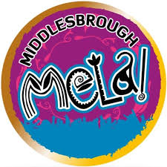

**Artist Commissions: Middlesbrough Mela 2021**

**INFORMATION PACK & APPLICATION FORM**

**EASY READ VERSION**



Middlesbrough Mela has two artist commission opportunities.



To animate Albert Park during Middlesbrough Mela Festival.

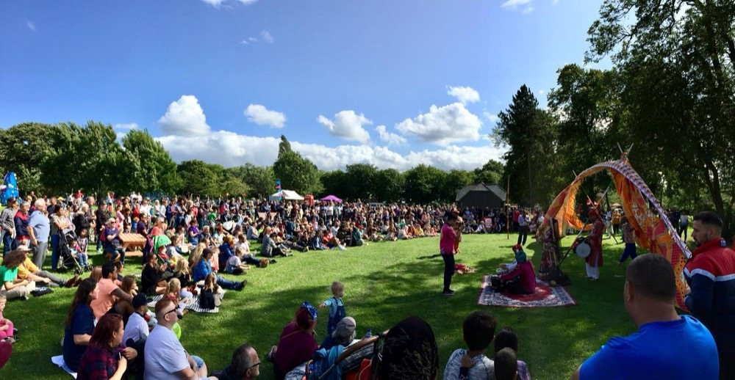

**About Middlesbrough Mela**

Middlesbrough Mela is one of the biggest and most spectacular multi-cultural festivals in the North-East and offers a fabulous mix of music, food, fashion and fun over two days!

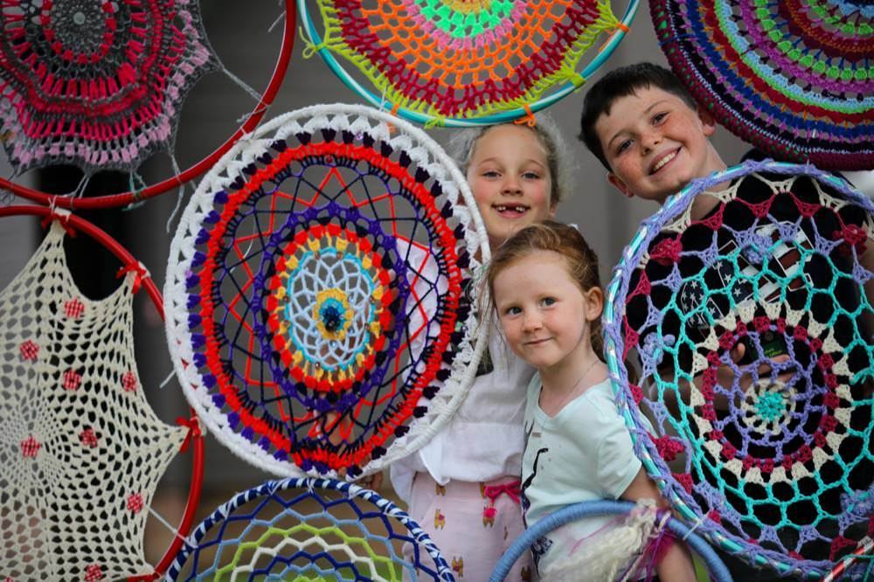

**About the year’s festival**

This year, as restrictions begin to ease, we’re delivering three smaller micro Mela festivals, that are more suit to the current COVID-19 climate.

On Sunday 8 August, at Albert Park, we will be focusing on family activities with arts and crafts, theatre, music, food, dance and a fun fair.

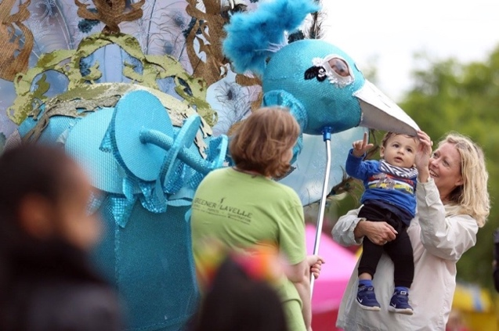



**About the commissions**

There are two commissions aimed at artists who want to create something new and wonderful to animate the site at Albert Park during Middlesbrough Mela festival.



**We will be awarding a maximum of two commissions of £2,500 each.**

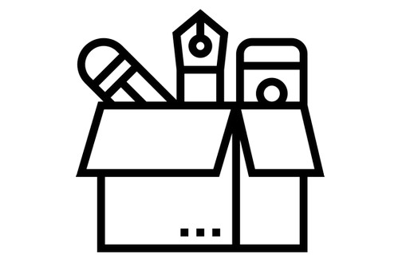

The budget is to cover all material costs and artistic fee in producing a product or item that will belong to Middlesbrough Council to be used at future Mela events.

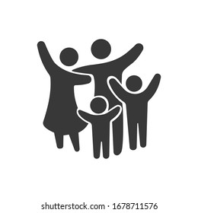

We are interested in ideas and designs that make areas of the park more exciting, fun and enjoyable for families.

The designs should embody the values of a multi-cultural festival and create wonder in a place that is known well by locals.

We would love something that is bold and vibrant for that festival feeling.

**Who can apply?**

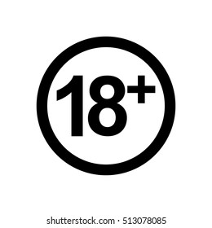

The commissions are open to artists aged 18 or above from anywhere in the UK.

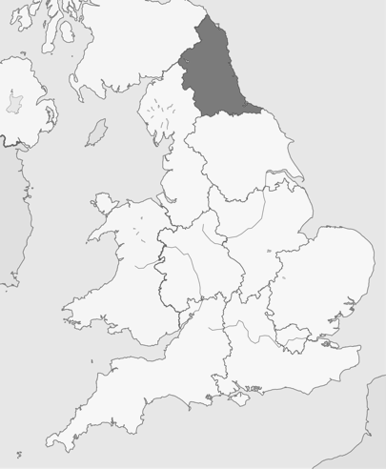

We are interested:

* Teesside/Middlesbrough based artists
* North East based artists
* Those would identify as People of South, East, West and Central Asian heritage, African and Caribbean heritage and mixed heritage
* Those who identify as d/Deaf and Disabled

**How to apply?**

Complete our short [Application Form](https://middlesbroughmela.co.uk/apply/) followed by the Equal Opportunities Form

Or through this easy read version and emailed to [amy@middlesbroughmela.co.uk](mailto:amy@middlesbroughmela.co.uk) (application below)





Or submit a video/voice-recording, no longer than 3 minutes, answering the information in the application. This can be sent via WeTransfer (or similar software) direct to [amy@middlesbroughmela.co.uk](mailto:amy@middlesbroughmela.co.uk)

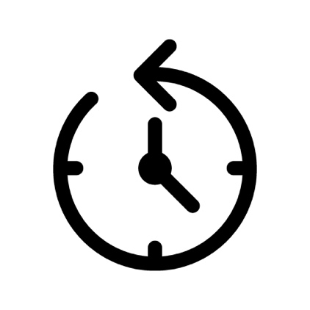

**Deadline**

**Stage One applications is Sunday 13 June 2021 at midnight**

**Stage Two**



If your Stage One application is successful, we will invite you to a Teams meeting to discuss your application, either **Thursday 17 June or Friday 18 June 2021**.

The commissions will be announced week commencing 21 June.



If you need any help, contact Amy – amy@middlesbroughmela.co.uk

**Application Form**

If you prefer, you can send your application via video or voice recording, at a maximum length of 3-minutes. Along with this Equal Opportunities Form: <https://middlesbroughmela.co.uk/equal-opportunities/>

|  |  |
| --- | --- |
| Name  Name Tag Png Transparent - chastity captions |  |
| Learn how easy to draw House cartoon step by step drawing tutorials - EASY  TO DRAW EVERYTHINGAddress |  |
| Email icon cartoon style Royalty Free Vector ImageEmail |  |
| Telephone Number  Telephone clipart cute, Picture #2118343 telephone clipart cute |  |
| Website/Social Media Links (if available)  1025px-Instagram-Icon - Out &amp; About Magazine  Facebook - Free social media icons |  |
| Tell us about your idea  What would you like to create?  (maximum 500 words)  Idea Clipart Idea Student - Girl With Light Bulb Clipart , Free Transparent  Clipart - ClipartKey |  |
| Tell us about your work  (maximum 350 words)  Flipchart Clip Art and Stock Illustrations. 1,887 Flipchart EPS  illustrations and vector clip art graphics available to search from  thousands of royalty free stock art creators. |  |
| Tell us how your idea links to Middlesbrough Mela, families, the local area, communities or has any cultural value  (maximum 250 words)  clip art link chain - Clip Art Library |  |
| Tell us about the materials you intend to use and how you thought about sustainability  (maximum 150 words)  Drop In Craft Days |  |
| Do you have a location in mind? (in Albert Park)  Straight Pin Clip Art - Royalty Free - GoGraph |  |
| Give an overview of the budget  Calculate Stock Illustrations, Cliparts and Royalty Free Calculate Vectors |  |
| Please complete this Equal Opportunities Form: <https://middlesbroughmela.co.uk/equal-opportunities/>  If you would like to provide any drawings or photos, to help us understand your idea, please email them, along with this application form to [amy@middlesbroughmela.co.uk](mailto:amy@middlesbroughmela.co.uk) | |